PELCO BioWave Laboratory Tissue Processing System
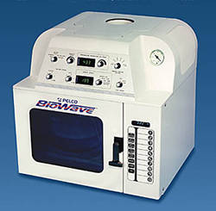
Why use a PELCO microwave?
- The ability to process tissue at low temperatures, allowing for optimum tissue feature and structure preservation. This feature is only available from us.
- System level integration with the load cooler, power controller and vacuum/bubbler in one cabinet. No installation or hookup required.
- Main Digital Display, which shows sample Probe Temperature or Water Load Temperature or Wattage setting.
- True variable wattage power control with 6 preprogrammed settings from 250 to 750 Watts
  - Smart power that automatically compensates for line voltage fluctuation to maintain constant microwave power
  - Digital display of set power for ease of calibration
  - LED indication of microwave magnetron "on" or "off"
- Temperature restriction set point is used to precisely control sample temperature
  - Digital display of sample temperature
  - PelGraph™ software for temperature charting, alarms, and data filing
  - Digital display of temperature restriction set point and continuously variable setting knob
  - PTFE-coated temperature probe
  - One-touch control pad and timer display:
    - 10 programmable one-touch keypads. Each can be programmed to run four stages up to 60 minutes, or all four included together for a total of up to four hours.
    - Manual time entry in minutes and seconds up to 60 minutes
    - Digital timer display counts down processing time
- Built-in load cooler recirculator to maintain an ambient uniform processing environment
  - Digital display of load temperature
  - Inclusion of the patented PELCO ColdSpot®, a temperature controlled processing surface which eliminates hotspots. This accessory allows you to use microwave exposure to process your sample without relying on specimen heating alone.
- Built-in air bubbler for adjustable sample solution agitation
- Integrated vacuum with continuous or automatic operation for variable time and pump/vent cycling
  - Vacuum Gauge displays vacuum achieved
- Vacuum and bubbler ports conveniently located near the front of the Microwave cavity
- Dual fans that provide continuous exhaust, supplying negative air movement when the chamber door is opened, keeping reagent vapors moving up the exhaust.
- Full line of accessories: PELCO TissueVac™ Vacuum Chamber; Sequenza™ Slide Processor, PELCO PrepEze™ Tissue Holder
- Laboratory engineered: The only UL-Certified microwave tissue processing system intended for laboratory use

PELCO BioWave DFR-10 Tissue Processing System
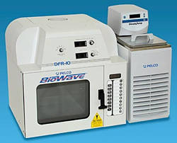
Why use a PELCO microwave?
- System maintains constant specimen temperature between 4°C and 40°C while applying continuous microwave energy up to 450 Watts.
- Main Digital Display, which can display either sample Probe Temperature or Wattage setting.
- True variable Wattage power control with 6 preprogrammed settings from 100 to 650 Watts
  - Smart power that automatically compensates for line voltage fluctuation to maintain constant microwave power
  - Digital display of set power for ease of calibration
  - Processing insert accessory that facilitates continuous circulation of reagent around specimens
  - LED indication of when the microwave magnetron is on and off
- SteadyTemp™ recirculator with 500 Watts chilling capacity
  - Maintains precise control of processing fluid and thus sample temperature
  - Reagent reservoir with 7 liter capacity
  - Recirculator provides continuous circulation to the Insert to remove boundary layer effects and extract the microwave heat
  - Digital display of processing fluid temperature
- Temperature restriction set point for over-temperature control
  - Digital Display of sample temperature
  - PelGraph™ software for temperature charting, alarms, and data recording
  - Digital Display of temperature restriction set point and continuously variable setting knob
  - PTFE-coated temperature probe
- One touch control pad and timer display
  - 10 programmable one-touch keypads. Each can be programmed to run four stages up to 24 hours each for a total of 96 hours
  - Manual time entry in hours and minutes up to 24 hours
  - Digital timer display counts down processing time
- DFR-10 Insert
  - Processing container holds 2 liters solution continuously exchanged with the SteadyTemp™ reservoir
  - Includes PTFE Cassette rack that holds 58 tissue cassettes
- Vapor Recovery system removes vapors from the SteadyTemp™ reservoir
- Full line of accessories: PELCO ColdSpot®, PELCO PrepEze™ and microwave sample accessories - all included
  - Integrated air pump draws vapors through a vapor trap into the main microwave exhaust
- Dual fans that provide improved continuous exhaust
- Can be used in conjunction with the 36115 PELCO ColdSpot® (optional) in place of the DFR-10 Insert for conventional tissue processing protocols

PELCO accessories
Accessories by Ted Pella.
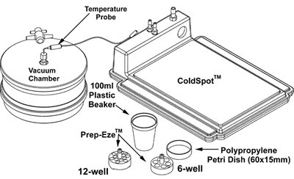
- PELCO® EM Microwave Vacuum Chamber
- PELCO® Coldspot
- PELCO® Microwave Capsule Holder
- PELCO® Prep-Eze™ Line of Tissue Holders

EMS 9000 Precision Pulsed Oven
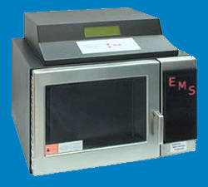
- 825 Watt nominal output with variable Wattage
- User-programmable presets and smart interface displays (Integrated on-board digital controller)
- Bubble Manifold for 5 tubes
- Forced exhaust system with fail safe interlock
- Adjustable duty cycle one second and greater for very precise process control
- Magnetron pre-warming
- Right side closet
- Vacuum system for rapid infiltration (optional)
- Load cooler/circulation system (optional)
- 3 different timer modes
- Multiple safety Interlocks
- Visual and Aural Warnings on errors and malfunctions
- All controls are automated
- Flexible temperature probe
Advantages of the EMS 9000 Precision Pulsed Laboratory Microwave Oven:
- Ease of use: User-friendly touch keypad to set and store all parameters - programmable
- Multiple running modes
- Multiple bubble mixing (5 ports)
- Adjustable temperature probe
- Ventilation
- Optional vacuum cycling for rapid infiltration
- Optional Load cooler
- Safety exhaust fans with fail safe interlock
- Integrated on board digital controller

EMS 820 Microwave Oven
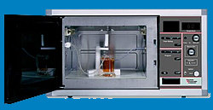
- Easy operation and maintenance
- Easily adjusted effect % knob
- Accurate temperature control
- Well ventilated chamber
- 3 different timer modes
- Built in air pump for mixing
- Manifold for up to 5 mixing tubes
- Adjustable temperature probe holder
- Stainless steel chamber
- Glass fiber reinforced silicone floor
- Built in reflector for even distribution of microwaves
- On/Off rotator switch

